Test Case: tc003_SPX_Dev5_Crear_Requisicion_Spot_Tipo_Cobro_CC_Urgent
Step 1 - Enter username and password and click to button Enter : Credentials Entered
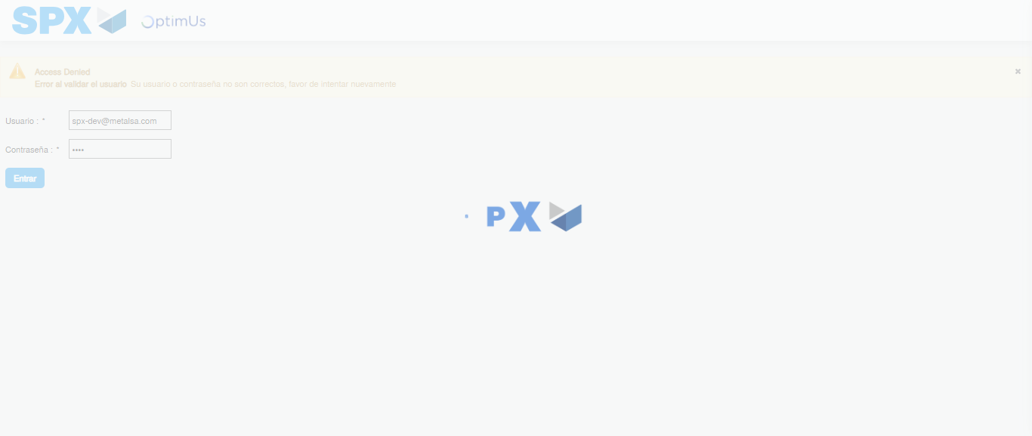Image file-name: QC_Testing-tc003_SPX_Dev5_Crear_Requisicion_Spot_Tipo_Cobro_CC_Urgent-1783356921225

Step 2 - Select to UEN and Access to Spot Buy Requisitions : UEN Correctly selected and Correct access
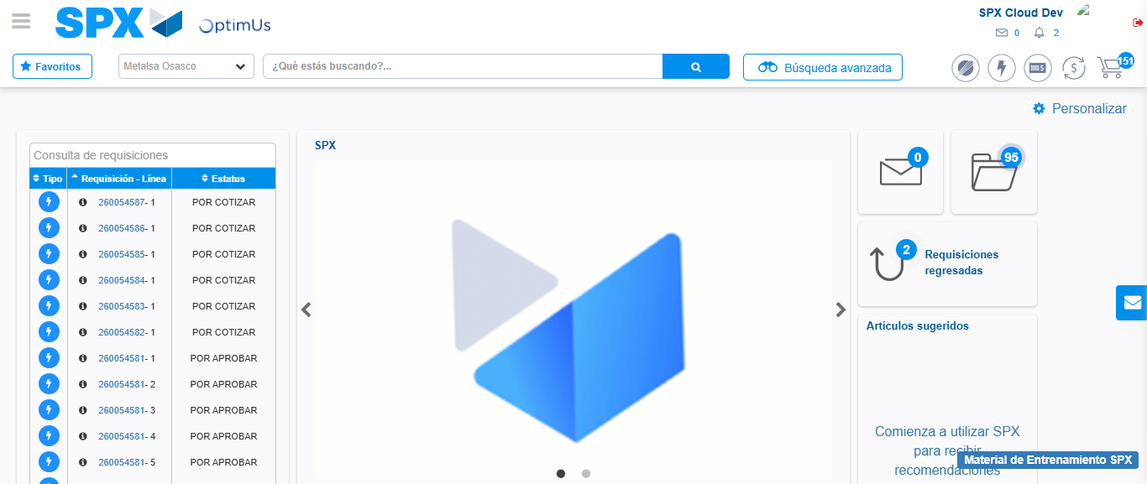Image file-name: QC_Testing-tc003_SPX_Dev5_Crear_Requisicion_Spot_Tipo_Cobro_CC_Urgent-1783356946554

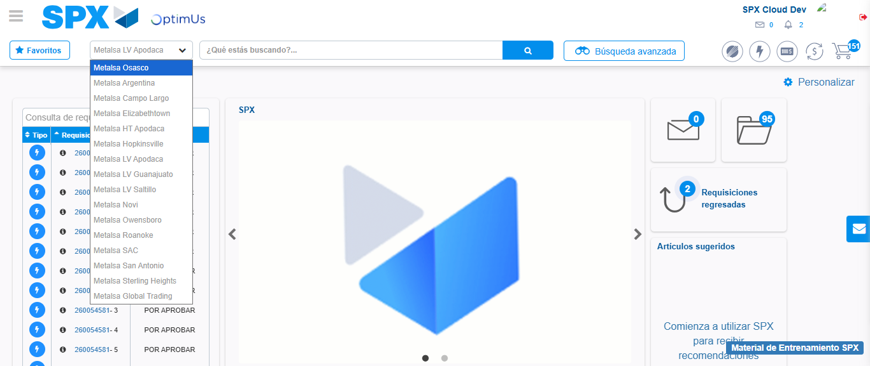Image file-name: QC_Testing-tc003_SPX_Dev5_Crear_Requisicion_Spot_Tipo_Cobro_CC_Urgent-1783356949380

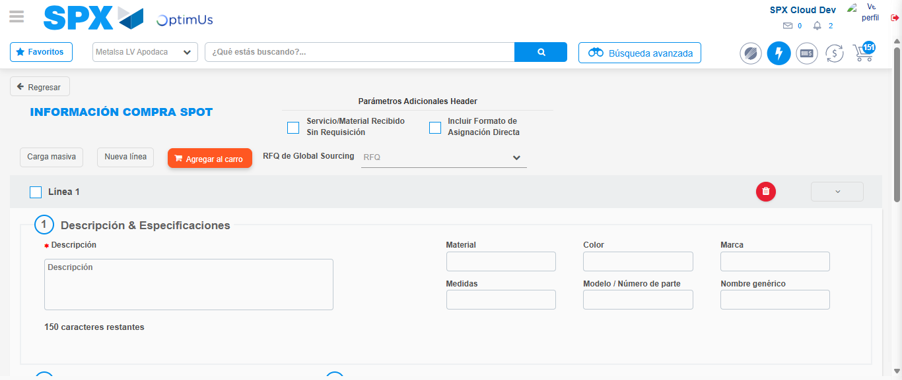Image file-name: QC_Testing-tc003_SPX_Dev5_Crear_Requisicion_Spot_Tipo_Cobro_CC_Urgent-1783356970028

Step 3 - Data Capture Spot Buy Requisition: Data captured correctly
Image file-name: QC_Testing-tc003_SPX_Dev5_Crear_Requisicion_Spot_Tipo_Cobro_CC_Urgent-1783356970253

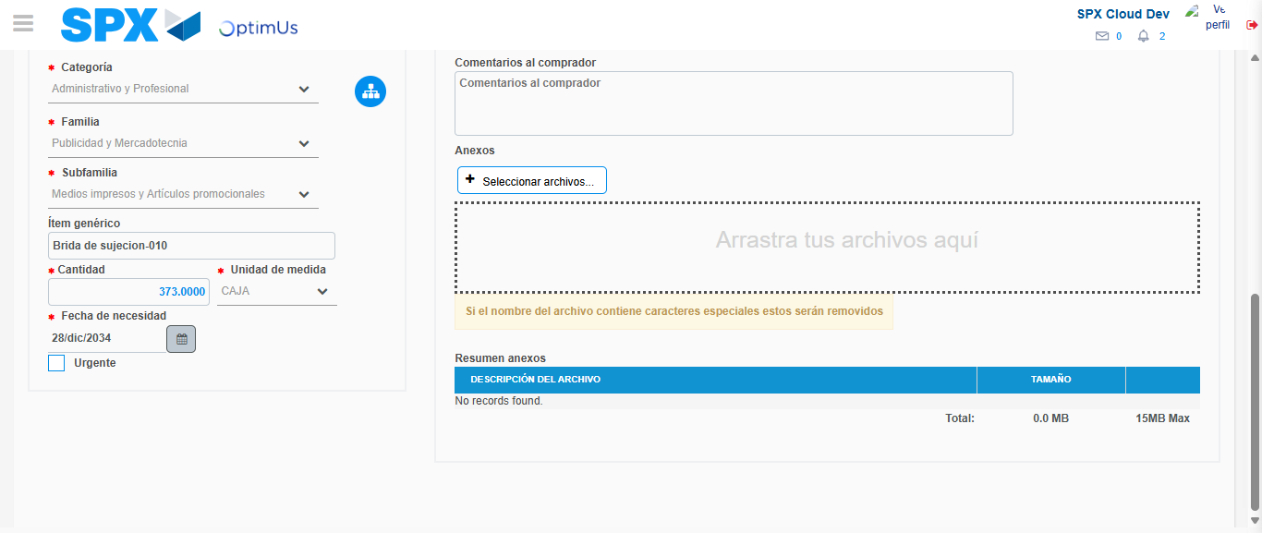Image file-name: QC_Testing-tc003_SPX_Dev5_Crear_Requisicion_Spot_Tipo_Cobro_CC_Urgent-1783356980680

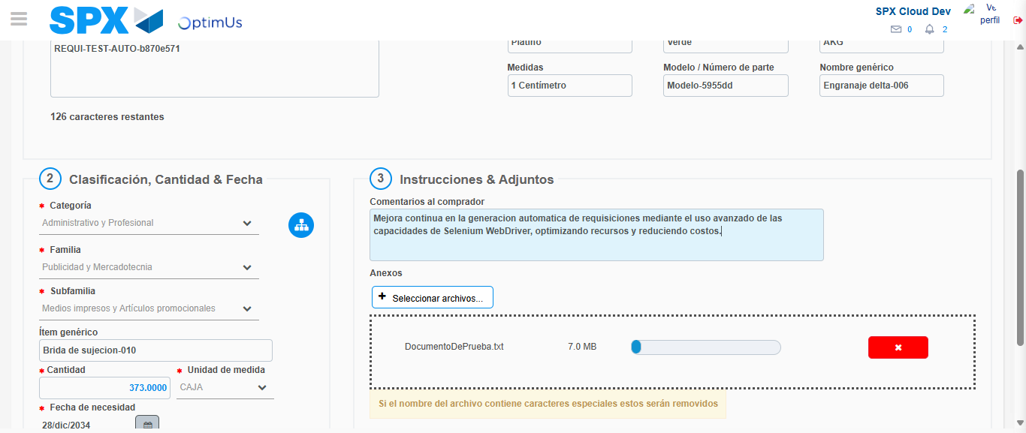Image file-name: QC_Testing-tc003_SPX_Dev5_Crear_Requisicion_Spot_Tipo_Cobro_CC_Urgent-1783356981429

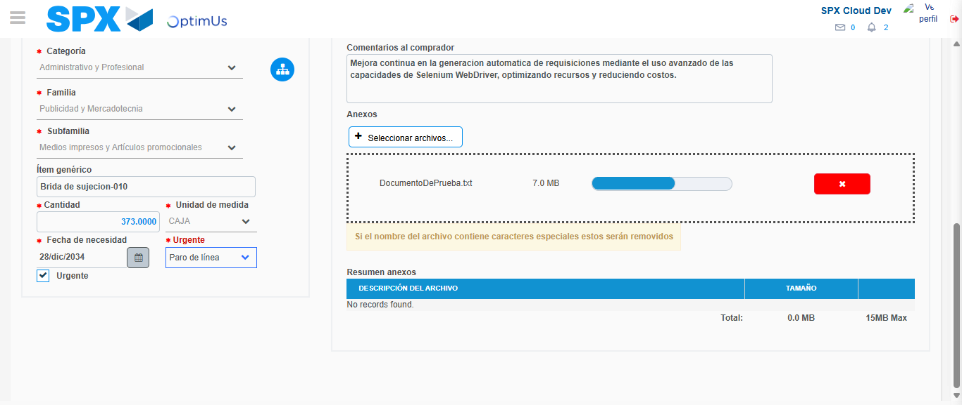Image file-name: QC_Testing-tc003_SPX_Dev5_Crear_Requisicion_Spot_Tipo_Cobro_CC_Urgent-1783356984986

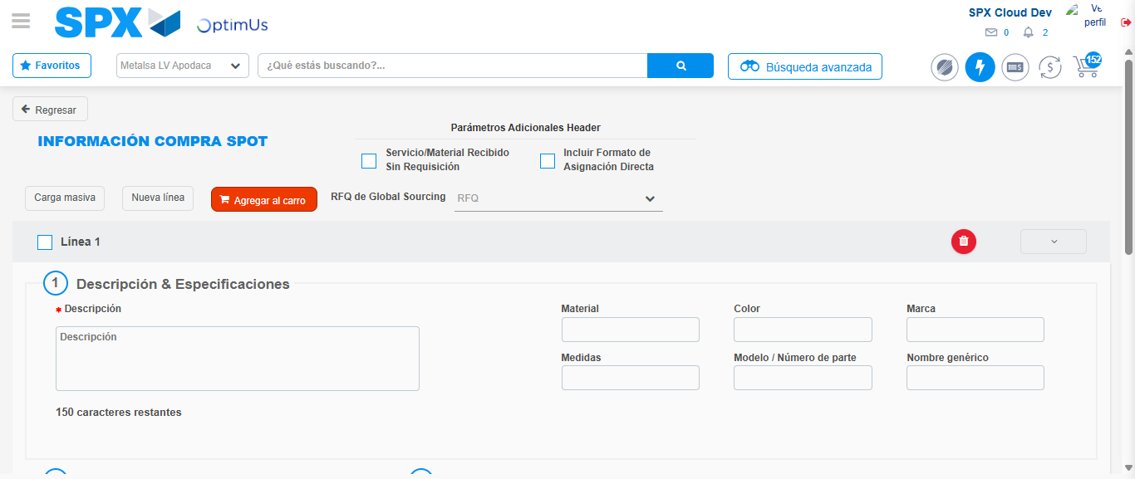Image file-name: QC_Testing-tc003_SPX_Dev5_Crear_Requisicion_Spot_Tipo_Cobro_CC_Urgent-1783356994641

Step 7 - Return to Main Page SPX : Return to Main Page SPX
Image file-name: QC_Testing-tc003_SPX_Dev5_Crear_Requisicion_Spot_Tipo_Cobro_CC_Urgent-1783356946554

Image file-name: QC_Testing-tc003_SPX_Dev5_Crear_Requisicion_Spot_Tipo_Cobro_CC_Urgent-1783356949380

Image file-name: QC_Testing-tc003_SPX_Dev5_Crear_Requisicion_Spot_Tipo_Cobro_CC_Urgent-1783356970028

Image file-name: QC_Testing-tc003_SPX_Dev5_Crear_Requisicion_Spot_Tipo_Cobro_CC_Urgent-1783356996846

Image file-name: QC_Testing-tc003_SPX_Dev5_Crear_Requisicion_Spot_Tipo_Cobro_CC_Urgent-1783356996989

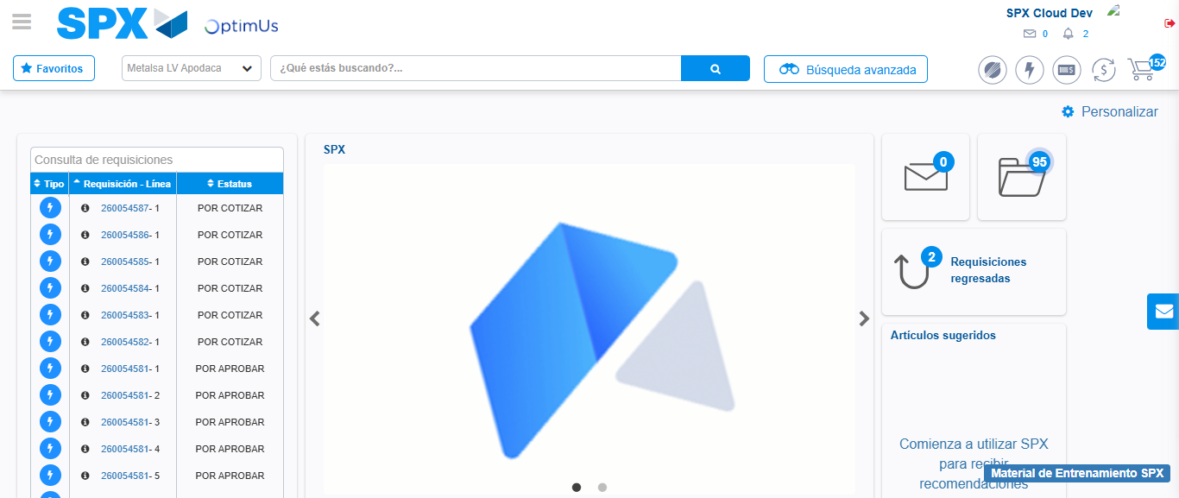Image file-name: QC_Testing-tc003_SPX_Dev5_Crear_Requisicion_Spot_Tipo_Cobro_CC_Urgent-1783357018128

Step 8 - Log Out : Log Out SPX
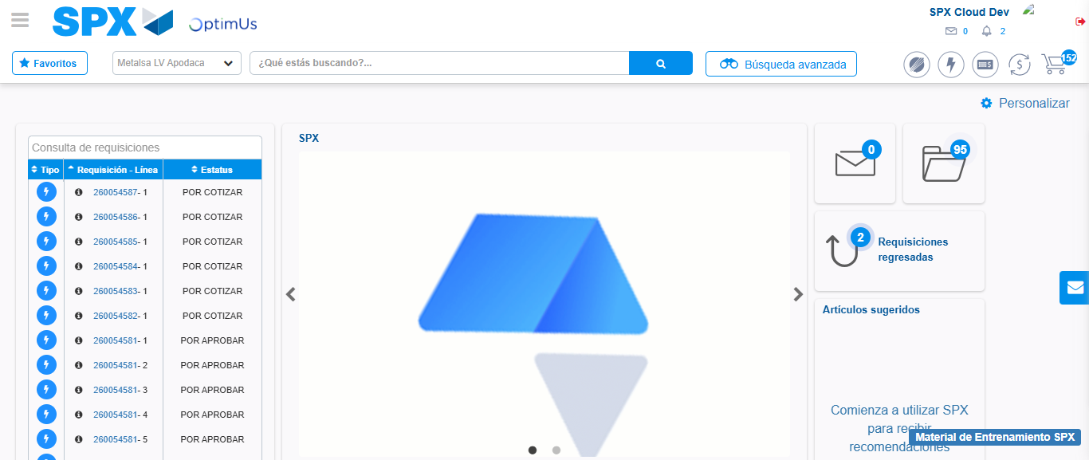Image file-name: QC_Testing-tc003_SPX_Dev5_Crear_Requisicion_Spot_Tipo_Cobro_CC_Urgent-1783357018409

